Should you change your niche?

Nicolas Cole
and
Dickie Bush
Apr 20, 2025
∙ Paid

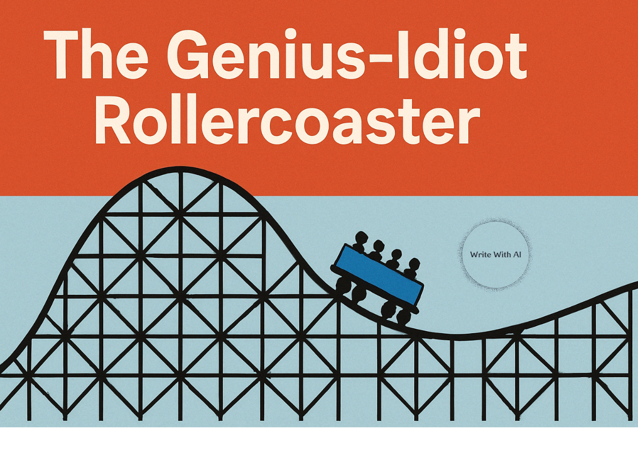

Do you ever think:
- Your niche is saturated?
- Your competition is too strong?
- The trend you’re writing in is dead?
If so, I’d like to introduce you to something I call “The Genius-Idiot Rollercoaster.”
The vast majority of entrepreneurs, business owners, and creatives ride this rollercoaster during their careers. And unfortunately, they use it as an excuse to give up on their business entirely when, in reality, it’s just a part of doing business.
I want to help you ride it so you don’t give up on your business too early (and help you make tons of cash in the process!).
And at the end of this post, I’ll give you a simple ChatGPT prompt that helps you coach yourself through the low points—so you don’t sabotage something that’s actually working.
Let’s dive in!
The Genius-Idiot Rollercoaster
Every time you start a new project or business, it takes a while for it to gain traction.
Let’s say you’ve just started a ghostwriting business.
You’ve spent a few weeks grinding away on outreach but without success.
- Your DMs go unanswered.
- Your social content isn’t attracting any leads.
- And, worst of all, you haven’t landed your first client.
At this point, the vast majority of people rationalize either switching niches/services or quitting entirely:
- “This niche is too saturated.”
- “No one can afford my services.”
- “Ghostwriting is dead, no one needs these services anymore.”
And they automatically ask:
“Should I change my niche as a ghostwriter?”
The vast majority quit.
But a small number of people hear these excuses yet decide to carry on.
They blame the system, “This doesn’t work for me Cole!” and almost give up.

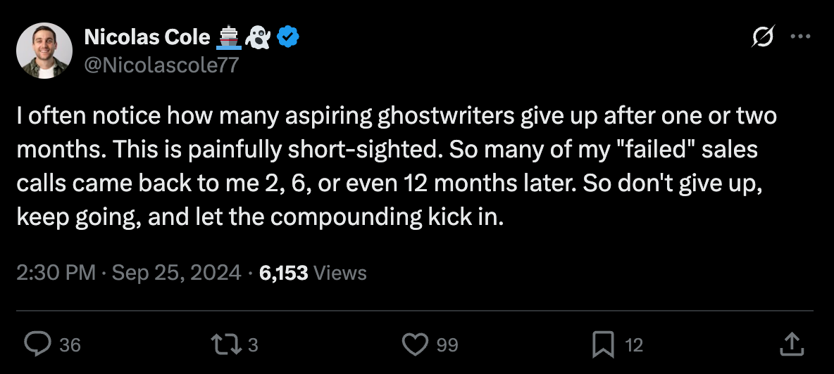

But, I always tell them to keep going.
Here’s why:
Riding Up High On The Rollercoaster
One day, all of a sudden, everything clicks.
- You land your first two clients.
- You’re making $10,000/month.
- You have people sliding into your DMs, asking how they can work with you.
Every single person who experiences this (especially the first time) comes to the same conclusion: “I’m a genius!” You think you were right all along, you always had it in you, you’re smart, capable, etc.
This feeling of euphoria will last a day, a week, or even months. It’s wild to see how people’s worldview completely changes (often over as little as 24 hours) when things are going right.
But then something will change in your business, a sinking feeling hits, and you start to ride the rollercoaster back down.
Riding Back Down The Rollercoaster
Here’s what happens:
- A couple of clients churn
- Your income drops by 60%
- You have an unhappy client
Suddenly, everything feels broken.
And those old rationalizations start to kick in:
- “My service doesn’t work anymore!”
- “No one can afford my services!” (even though someone paid you for them last week!)
- “This niche is dead, it’s time to pivot.”
Can you see the pattern here?
How This Applies To Anything & Everything You Try To Create
This applies to any business or creative endeavor you start and continue to grow.
This rollercoaster ride is a universal experience. And to prove my point, I’m going to share a non-ghostwriting example.
I have a close friend who's a therapist and life coach. When he graduated from grad school, I helped him get his business up and running. In the beginning, he said his only goal was to make $100k/year, and if he could do that, he would be happy. That’s $8k/month.
I told him that was completely doable. So I helped him work on:
- His sales pitch
- His positioning
- His messaging to his ideal client
And, in the first couple of months, it was the same as everybody else. He didn't believe that it was going to happen. He trusted me, but he was skeptical (and his wife was even more skeptical and wanted him to get a practice job for something more “reliable”).
But eventually, he started landing clients.
Nothing had happened for months, but then all of a sudden, it clicked and he hit his $8k/month goal.
Then a couple of months later, some of those clients churned. This is very normal in any service business. But it didn’t mean his business was dead.
He called me in an absolute panic:
- “I knew this was too good to be true!”
- “I don't think my coaching offer works anymore!”
- “I think I need to change niches and go after a different type of client!”
Over a two-hour conversation, he gave me every rationalization you could possibly think of.
I had to talk him off the ledge and tell him, “Dude, it happens—this is just part of the game. This is what running a service business looks like. Relax!”
But he couldn't relax because he was now at the bottom of the rollercoaster and the only thing he felt in that moment was that:
- He was an idiot .
- He was an idiot for thinking he could do this.
- And he was an even bigger idiot for trusting me!
Then, three days later, 3 new clients all came through the door and signed in the same week.
He calls me again and says (yep, you guessed it), “Cole, I'm a genius! I knew everything was fine. I have an amazing business and I have an amazing niche and offer!”
To this day, I talk with him on a weekly basis and we have some variation of this conversation every couple months for the past 5 years ever since he started his coaching business.
Manage The Highs, Coach The Lows
The moral of the story is that this is inevitable it's part of the process and neither extreme is true:
- When things are going well, you aren't a genius. They are going well because you’ve executed the fundamentals consistently over a reasonable period of time
- And when things aren't going, you aren't an idiot. They just stopped working because you stopped executing the fundamentals in some way or another but that doesn't mean your business is about to die.
And this can be applied to businesses and even within businesses.
- Every single business has good months and bad months.
- Every worker and team member inside of every business has good months and bad months.
- Every single person trying to create anything in the world has good months and bad months.
This means the skill to build here is learning how to be level-headed despite being chained to The Genius-Idiot Rollercoaster because it's going to happen either way.
You're going to feel manic when things are going great and you're going to feel depressed when things aren't going great. But if you can manage the highs and coach yourself through the lows, then neither extreme will last forever.
Otherwise you aren't running your business, your business is running you.
Now, I wish I could help everyone just like my friend.
But the reality is I can’t. So, I came up with the next best thing…
A ChaGPT prompt to coach you off the Genius-Idiot Rollercoaster:
This simple prompt helps you separate your mood from your metrics.
- It forces you to slow down and explain what’s going on
- It gives you practical, unemotional feedback
- And it stops you from blowing up something that might actually be working
Here’s the prompt:
I want you to act like my no-BS level-headed writing coach.

This week, I feel like [GENIUS/IDIOT] because:

[insert what happened].

Your job is to:
- Help me separate facts from feelings
- Help me unpack what I did to create the result
- Help me see what's repeatable, avoidable, or random
- Help me identify what I need to change and what to do next
- Remind me what actually matters

Ask me one question at a time to help me get to the root of the emotions and facts before making any recommendations.
To use this prompt, describe your situation just like you’d vent to a friend.
No need to sound polished. Just fill in the blanks honestly:
“This week, I feel like a total [GENIUS/IDIOT] because…”
Then hit enter—and let ChatGPT guide you like a calm, rational coach.
It’ll ask you one question at a time to help you:
- Zoom out from the emotional spiral
- See what’s actually working (even if it feels like everything’s broken)
- Find the small levers that move you forward
Use it whenever you’re tempted to quit, pivot, overanalyze, or even if when you’re super proud of an accomplishment.
Why this works
Every time you do this, you retrain your nervous system to ride the ups and downs without rewriting your entire business model.
And over time?
- You stop changing direction every 6 weeks
- You stop blowing up systems that were working
- You start making decisions from strategy, not fear
That’s the skill most creators never build.
Not writing. Not marketing.
Emotional durability.
If you’re stuck, it’s probably not because your idea sucks. It’s because your mood is running your roadmap.
Don’t scrap the plan. Sit with it.
Don’t change the niche. Coach yourself out of the dip.
That’s it.

